## 2.5 Logical View of the Systems

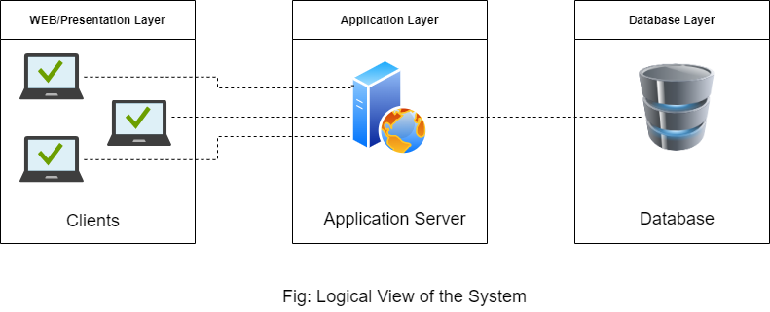

Figure : Logical View of the System

The above diagram shows the logical view of the Event master system. It is composed of three different layers, namely WEB/Presentation layer, Application layer, and Database Layer.

* WEB/Presentation layer: This layer is where most of the data are processed before interacting with the system. It is developed using html, CSS, and JavaScript.
* Application layer: In this layer, the clients interact with the system. It is also regarded as the connection between application layer and a database layer. In order to interact with the database layer and a presentation layer, a connection has been made using PHP. Client users will interact with this layer to book their events and manage their event details.
* Database layer: This is the layer where all the information inserted from the frontend are stored and we can easily fetch the data as per our requirement. This will contain all of the user data such as their current and past events, their existing queries, and

## 2.6 Functional View of System by Components

### 

### 

### 2.6.5 Event Booking

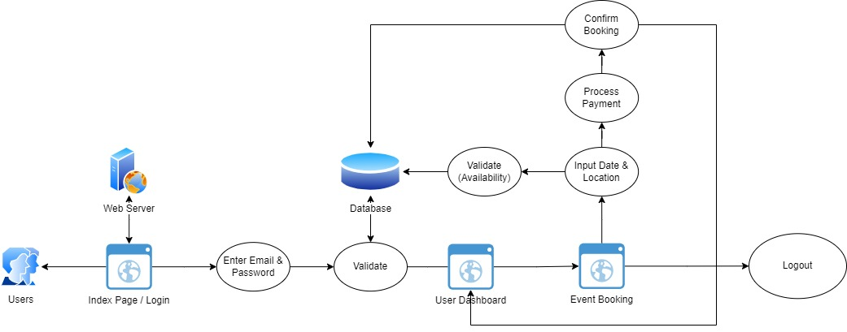

Figure : Event Booking

### 2.6.6 Manage Booking

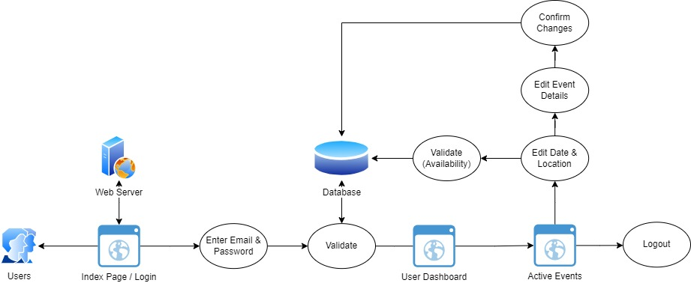

Figure : Manage Booking

### 2.6.7 Client User Query

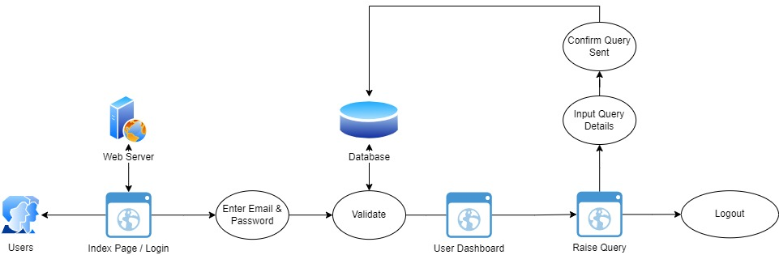

Figure : User Query

### 